**Arduino Solenoid Door Lock using RFID**

**Introduction**

It’s a cost-effective and secure door locking system. RFID (Radio Frequency Identification) will be used to verify identity for access control and security. There will be auto lock and unlock features. Its application lies in hotels, offices, and many other places where you just have to place the card near RFID reader for a second and the door will be opened. Also, a Hall Effect sensor and a magnet are used to detect the door movement. Hall Effect sensor will be placed on the door frame and the magnet on the door itself. When the Hall Effect sensor and magnet are close to each other, Hall Effect sensor will be in a low state and the door will remain closed, and when the sensor and magnet are not close means the door is open and hall sensor is in the high state. We will use this Hall Effect mechanism to lock and unlock the door automatically. For additional security, a phone application via Bluetooth will be connected which will send prompt on invalid authentication attempts and also track the user data.

**Circuit Diagram**

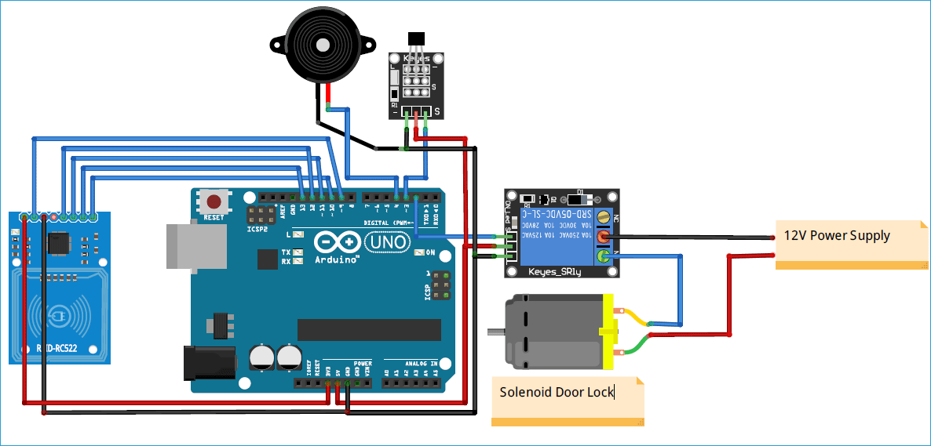

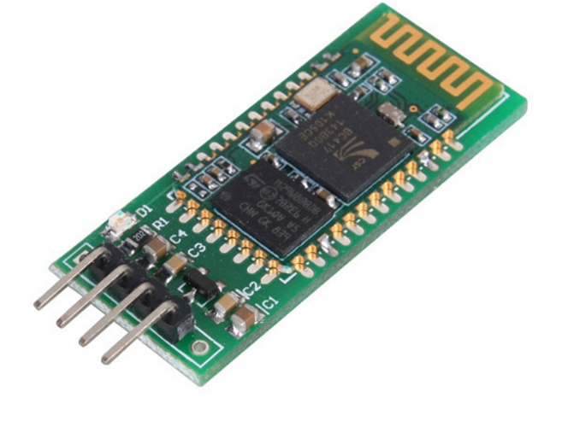Apart from the above there will be a Bluetooth module too for prompt system.

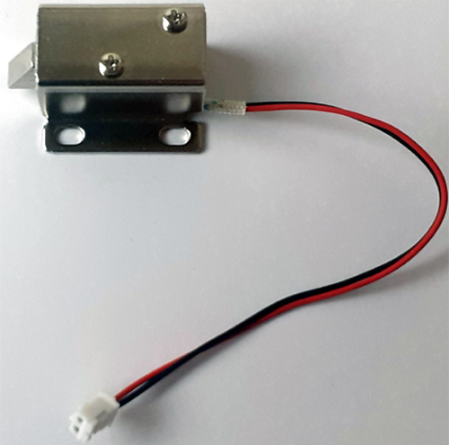For locking purpose, a solenoid lock will be used.